Evaluating Ultrasonic Sensor for developing Flood Monitoring and Alerting System Tinkercad Simulation

MARK DAREL B. SALIGUMBA (Student)

Department of Electrical Engineering, College of Engineering, Architecture and Industrial Design

Bohol Island State University-Main Campus, [markdarel.saligumba@bisu.edu.ph](mailto:markdarel.saligumba@bisu.edu.ph)

MAX ANGELO PERIN (Instructor)

Department of Electrical Engineering, College of Engineering, Architecture and Industrial Design

Bohol Island State University-Main Campus, [maxangelo.perin@bisu.edu.ph](mailto:maxangelo.perin@bisu.edu.ph)

Imaginative Abstract. Low-cost sensors' widespread availability and vast range of applications have fueled demand for better sensor performance. To address the designers' requirement for simpler systems, integrated sensors are being created. Smart sensors are becoming essential components of systems that perform operations that were previously impossible or uneconomical to do.  One example of a smart sensors is Ultrasonic sensor, an ultrasonic sensor detects and measures the distance between two objects. It determines distance by producing ultrasonic and receiving the wave reflected by the object. Ultrasonic sensors are commonly used in water-level sensing; it can be accomplished by positioning one sensor above a water surface also ultrasonic sensors can even measure fluid flow rates, an emitter and a receiver (separate in this form) are aligned with the flow of a fluid in the simplest situation. Since sound travels via a moving medium, the velocity of the fluid will affect the speed of sound in relation to these factors. Thus, ultrasonic sensors are a major component to develop a Flood Monitoring and Alerting System.

**CCS CONCEPTS** • Hardware • Emerging Technologies • Electromechanical Systems • Microelectromechanical Systems

**Keywords:** Ultrasonic Sensors, Smart Sensors, Flood Monitoring and Alerting System, Emitter and Receiver.

ACM Reference Format:

**MARK DAREL B. SALIGUMBA, Max Angelo Dapitilla Perin,** 2022. **Evaluating Ultrasonic Sensor for developing Flood Monitoring and Alerting System Tinkercad Simulation (ACM:IA-I-RRL-PM-R-A)**. In Research Project Presentation for Bachelor of Science in Electrical Engineering 3 in CPE 03 – Microprocessor Systems S.Y. 2021-2022, 2nd Semester, Bohol Island State University-Main Campus, Tagbilaran City, Republic of the Philippines. ACM, New York, NY, USA

1. INTRODUCTION

Increased human activity, as a result of population growth, lifestyle changes, and economic development, has resulted in a high need for personnel, particularly in cities around the world. Security officers at the gates to monitor the movement of people who may be intruders, traffic police on highways to monitor traffic, care givers in homes for the elderly or sick, automatic doors, washing, wireless Sensor-Based Driving Assistant for Automobiles, and many other services are becoming increasingly necessary. Humans are prone to human mistake and limits when used to sense motions and other human actions. By this ultrasonic sensor is helpful to distinguish any activities to ease human works. As a developing world humans must adapt to new inventions.

Among these applicable sensors, the ultrasonic HC-SR04 has played a significant participation in radar-like projects. In [1]the ultrasonic sensor was used to measure the distance in an intelligent system designed for obstacle avoidance. Shrenika R M et al [2] implemented a controlled system for monitoring the water level in a tank. The ultrasonic sensor is utilized as a component to measure the water depth which is fed to an Arduino to control a water pump according the water level in the tank. An array of ultrasonic sensors is used in a closed room to provide an assist for a person fall warning [3]. This study aims to evaluate ultrasonic sensor for Flood Monitoring System, this tool is the main source of information as it commonly used in water-level sensing.

1. REVIEW OF LITERATED LITERATURE

This among other reasons have necessitated automated sensing that could be recorded for future reference and also remote. Samuel Bango was the first person to invent a motion detector whereby he came up with a burglar alarm in the early 1950s. Doppler Effect is the main principle upon which Bango motion detector is based on [4]. Majority of motion detectors today still employ the same principle for example, use of the Doppler Effect to sense gestures [5]. Other sensors include IR sensors, ultrasonic sensors and microwave sensors which by the change in the frequencies they emit they are able to sense motion [6].

* 1. HC-SR04 Ultrasonic Sensor

The HC-SR04 ultrasonic sensor (like the one shown in figure 2.1) uses SONAR to determine the distance of an object just like the bats do. It offers excellent non-contact range detection with high accuracy and stable readings in an easy-to-use package from 2 cm to 400 cm or 1” to 13 feet. The operation is not affected by sunlight or black material, although acoustically, soft materials like cloth can be difficult to detect. It comes complete with ultrasonic transmitter and receiver module.

The ultrasonic sensor uses the reflection of sound in obtaining the time between the wave sent and the wave received. It usually sent a wave at the transmission terminal and receive the reflected waves. The time taken is used together with the normal speed of sound in air (340ms-1) to determine the distance between the sensor and the obstacle. The Ultrasonic sensor has been used by several researchers to sense the movements of the objects as they approach it [7].

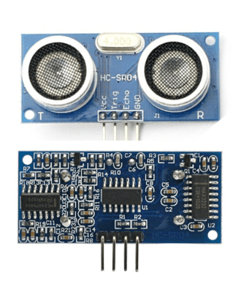

**Figure 2.1.** Ultrasonic sensor

* + 1. HC-SR04 Ultrasonic Sensor Features and Specifications

In figure 2.1.1 it shows some of the HC-SR04 ultrasonic sensor features and specifications.

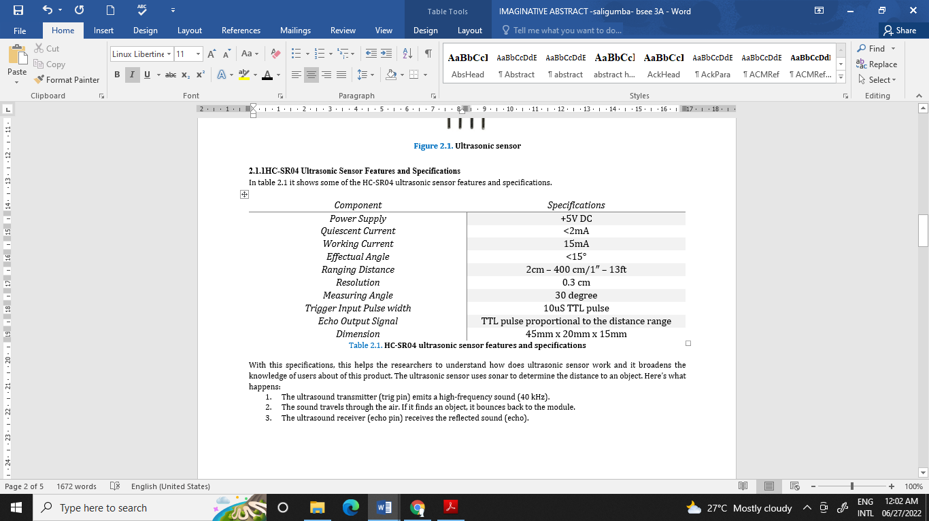

**Table 2.1.1.** HC-SR04 ultrasonic sensor features and specifications

With this specifications, this helps the researchers to understand how does ultrasonic sensor work and it broadens the knowledge of users about of this product. The ultrasonic sensor uses sonar to determine the distance to an object. Here’s what happens:

1. The ultrasound transmitter (trig pin) emits a high-frequency sound (40 kHz).
2. The sound travels through the air. If it finds an object, it bounces back to the module.
3. The ultrasound receiver (echo pin) receives the reflected sound (echo).

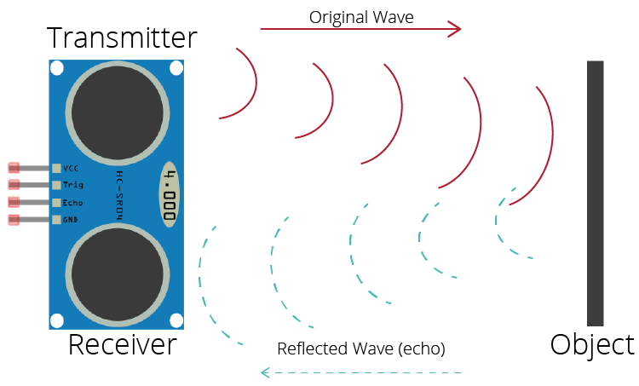

**Figure 2.2.** Shows how Ultrasonic sensor work

Figure 2.2 shows how ultrasonic sensor work, ultrasonic sensor uses the reflection of sound in obtaining the time between the wave sent and the wave received. It usually sent a wave at the transmission terminal and receive the reflected waves [8].

* 1. Configuration of HC-SRO4 ultrasonic sensor with Arduino

This sensor operates as a transmitter-receiver system for ultrasound waves. Figure 2.3, illustrates the pin configuration of this sensor module with the Arduino board. The power pins represented by the VCC and GND which are attached to the 5 V and GND pins respectively on power pins of Arduino. The other two pins are the trig and the echo which are used to trigger the transmitter to generate 8 ultrasonic pulses and receive the reflected echo from an object within the detected range. For the calculation of the distance of any object, let an object located at 10 cm away from the sensor, it is well-known that the speed of the sound is 340 m/s and to make the calculation more convenient for the case of experimental circuits, the speed is considered as 0.034 cm/µs. so, in order to measure the distance (D), we need to count the elapsed time (t) of wave travelling towards the object and return back, then use it as in equation [9].

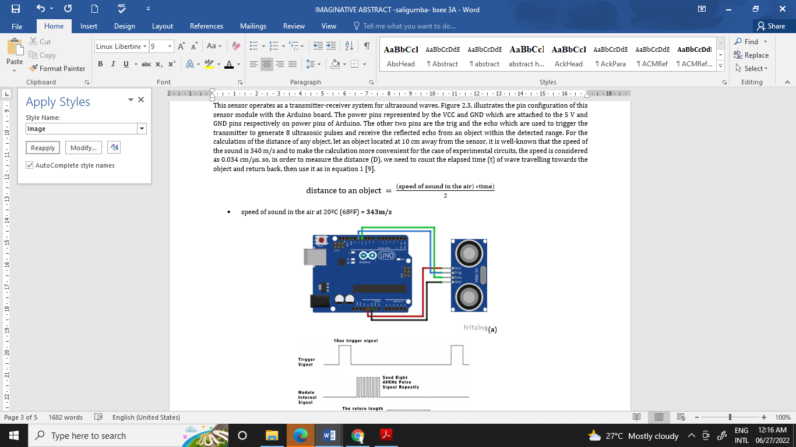

* speed of sound in the air at 20ºC (68ºF) = **343m/s**

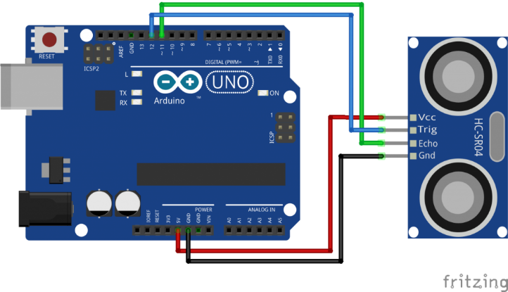(a)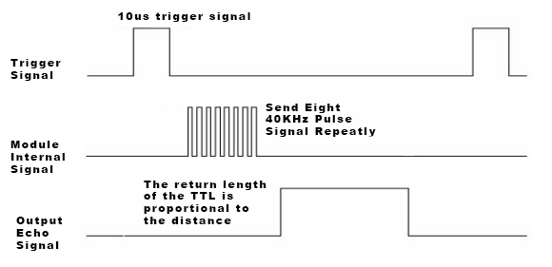 (b)

**Figure 2.3.** Shows Ultrasonic Sensor module (a) connections (b) operation principle

1. PROPOSE METHODOLOGY

The purpose of this project is to sense the water level in river beds and check if they are in normal condition. If they reach beyond the limit, then it alerts people through LED signals and buzzer sound. Also it alerts people through Sms and Emails alerts when the water level reaches beyond the limit. The main sensing component of this study is HC-SR04 ultrasonic sensor. For the process of this study, the researcher’s identity the materials needed to complete the simulation in the tinkercad.

The materials were connected as follows. The Arduino Uno was fixed to the breadboard and the jumper wires were connected. One jumper wire from the 5-volt pin on the Arduino was connected to the to the bottom channel of the breadboard. Another jumper wire from a ground pin on the Arduino was connected to the upper channel of the breadboard. Piezo Buzzer has two terminals. Positive and negative. The positive terminal was connected to the pin 13 at the Arduino while the negative part was interfaced with 330 Ohms resister and connected to the lower channel of the breadboard. The ultrasonic sensor has four pins that’s Vcc, Trig, Echo and ground. Echo was connected to pin number 11 while Trig being connected to pin number12 in the Arduino Uno. Vcc was connected to the upper channel while the Ground (GND) to the lower channel of the breadboard. The study utilized three LEDs one red, 1blue and greens. LED1 was connected to the pin number 8 and LED2 to pin number 7, LED3 to pin number 6. The negative terminal was interface with the 330 Ohms resisters to the lower channel of the breadboard.

REFERENCES

[1] Y. L. S. L. J. S. H. a. W. Y. Jin, "Design of an Intelligent Active Obstacle-Avoidance Car based on rotating Ultrasonic sensor," pp. 753-757, 2018.

[2] R. C. S. K. A. D. Y. a. S. R. Shrenika, "Non-Contact Water Level monitoring system implemented using labview and arduino," pp. 306-309, 2017.

[3] C. a. C. Nadee, "Ultrasonic array sensor for monitoring of human fall detection," pp. 1-4, 2015.

[4] "Hiroaki Otani Inventions, Patents and Patent Applications - Justia Patents Search," [Online]. Available: https://patents.justia.com/inventor/hiroaki-otani?page=2.

[5] U. Lab, "SoundWave: Using the Doppler Effect to Sense Gestures".Ubicomplab.cs.washington.edu.

[6] &. Z. W. H. Zhao, "Motion Measurement Using Inertial Sensors, Ultrasonic Sensors, and Magnetometers With Extended Kalman Filter for Data Fusion," Ieeexplore.ieee.org.

[7] S. M. B. S. B. J. G. S. N. Soni, "Distance Measurement Using Ultrasonic Sensor and Arduino," International Journal of Engineering Science and Computing, pp. 1-2, 2017.

[8] "Complete Guide for Ultrasonic Sensor HC-SR04 with Arduino | Random Nerd Tutorials," Random Nerd Tutorials.

[9] N. I. A. e. al., "Investigating the resolution ability of the HC-SRO4 ultrasonic sensor," IOP Conf. Ser.: Mater. Sci. Eng. 745, 2020.

APPENDICES

**A.1 TinkerCad Simulation**

<https://www.tinkercad.com/things/jA4xCDrLPwD-sizzling-tumelo/editel>

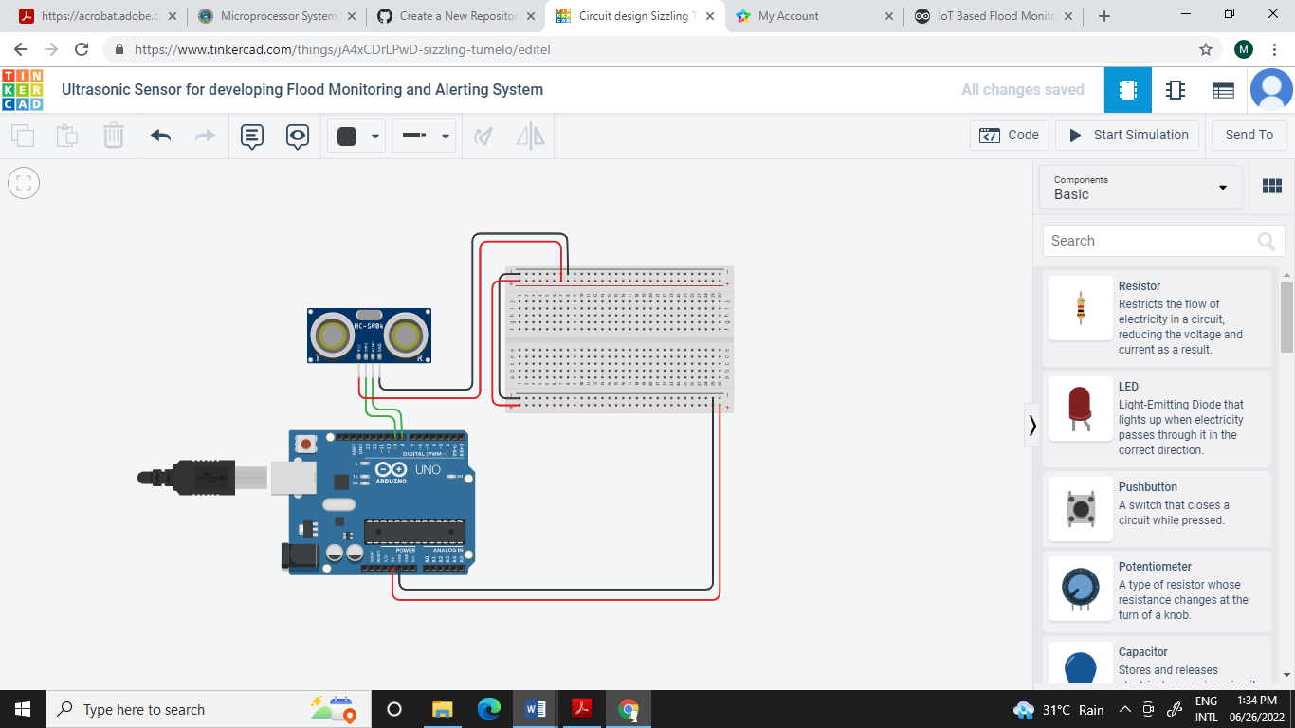

**A.1 Meister Task**